LINUX LCM/BACKLIGHT 部分配置文件说明
- 功能说明
1.显示设备配置
显示部分目前可以支持LCD,CVBS,YPBPR,HDMI等4种输出。其中后面3中一般只能配置分辨率或者显示格式，而LCD部分可以配置，LCD部分包含LCD,LVDS,TCON,CPU等控制器可以配置。
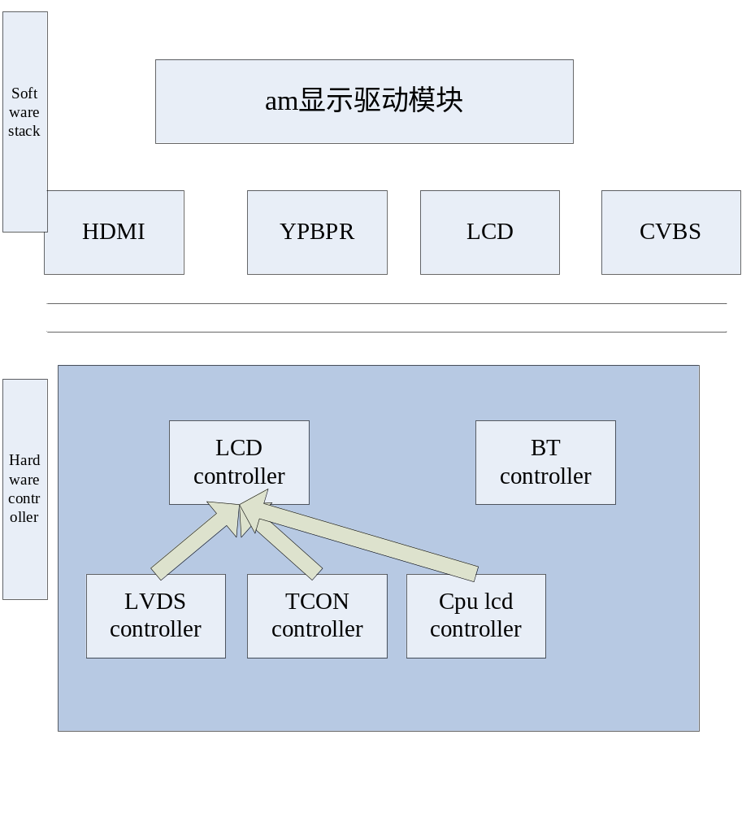 HDMI配置：timing_format.
YPBPR配置：timing_format
CVBS配置: PAL或者NTSC
LCD配置： LCD控制器部分（timing,DAC,RGB）,LVDS控制器部分（如果LVDS），TCON部分控制是固定的，所以只需要确定是否使用TCON。

2.背光/VGL/VGH电源部分配置
主要是IC内置的PFM,PWM模块的设置。
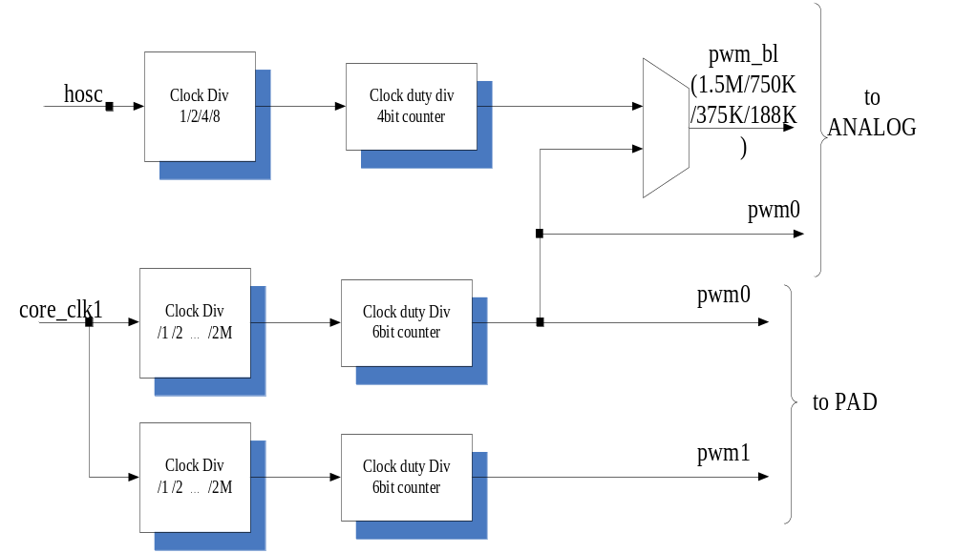 IC提供pwm0_ctl,pwm1_ctl等控制PWM0,PWM1, CMU_FM_PMCLK来控制PWM_BL，BL_CTL来控制PFM模块和PWM模块。
因此只需要控制这4个寄存器就可以控制VGH/VGL，背光等。调节背光可以根据需要调试4个寄存器其中的一个。
- 基本数据结构
- LCD 部分配置
enum lcd_type{
LCD_TTL = 0,
LCD_LVDS,
LCD_TCON,
LCD_CPU,

};

enum interface_type{
LCD_16P = 0,
LCD_18P,
LCD_24P,
LCD_16S,
LCD_18S,
LCD_24S
};
struct lcm_config{
unsigned char lcm_type; //tcon lvds cpu just for decription
unsigned char lcd_bt;
unsigned char lvds_en;
unsigned char tcon_en;
unsigned char cpu_en;
unsigned char d_clk;
unsigned short device_width;
unsigned short device_height;
unsigned short image_width;
unsigned short image_height;

unsigned short hbp;
unsigned short hfp;
unsigned short hswp;
unsigned short vbp;
unsigned short vfp;
unsigned short vswp;
unsigned int rgb_ctl;
unsigned int dac_ctl;

unsigned char lvds_format;
unsigned char lvds_channel;
unsigned char lvds_swap;
unsigned char lvds_map;
unsigned char lvds_mirror;

unsigned char lcm_rgbformat;

unsigned int lcm_reserve1;
unsigned int lcm_reserve2;
unsigned int lcm_reserve3;
unsigned int lcm_reserve4;
unsigned int lcm_reserve5;

}__attribute__((packed));

2. LCM部分配置
enum display_device_type{
LCD = 0,
HDMI,
YPbPr,
CVBS,
BTTV,
NULL_DEVICE
};

enum hdmi_timing{
/// SMPTE 274M
FMT_2200x1125_1920x1080_60I,
FMT_2640x1125_1920x1080_50I,

FMT_2200x1125_1920x1080_30P,
FMT_2640x1125_1920x1080_25P,
FMT_2750x1125_1920x1080_24P,
/// SMPTE 296M
FMT_1650x750_1280x720_60P,
FMT_3300x750_1280x720_30P,
FMT_1980x750_1280x720_50P,
FMT_3960x750_1280x720_25P,
FMT_4125x750_1280x720_24P,

FMT_2304x1250_1920x1152_50I,
/// ITU-R-656
FMT_858x525_720x480_60I,
FMT_864x625_720x576_50I,
/// SMPTE 293M
FMT_858x525_720x480_60P,
FMT_864x625_720x576_50P,

FMT_1250x810_1024x768_60P,
};

enum cvbs_format{
PAL = 0,
NTSC
};

enum ypbpr_timing{
YPBPR_1080P = 0,
YPBPR_720P,
YPBPR_576P,
YPBPR_576I,
YPBPR_480P,
YPBPR_480I
};

struct am7xfb_config_file{
char default_device; //lcd ypbpr cvbs hdmi
union{
int timing_format; //hdmi ypbpr cvbs
struct lcm_config lcm;
};
}__attribute__((packed));

3.PFM/PWM部分配置
/******** backlight adjust format ***************/
#define PWM0_DUTY_ADJUST 1
#define PWM1_DUTY_ADJUST 2
#define CMUFM_DUTY_ADJUST 3
#define PFM_FEEDBK_ADJUST 4
#define PWM_FEEDBK_ADJUST 5

/******** backlight switch format***************/
#define GPIO_SWICH 1
#define PFM_SWITCH 2
#define PWM_SWICTH 3

struct am7x_bl_config{
unsigned char bl_en;
unsigned char switch_format;
unsigned char adjust_format;
unsigned long bl_ctl;
unsigned long cmu_fmclk;

unsigned long pwm0_ctl;
unsigned long pwm1_ctl;
unsigned char gpio;
}__attribute__((packed));

